# **IST769 Homework Submission**

Name: **Sathish Kumar Rajendiran**   
SUID: **666555028**  
Email: **srajendi@syr.edu**  
Date Due: **07/20/2021**    
Homework #:**2**

# **Exercise(s):**

1. **Use built in SQL functions to write an SQL Select statement on fudgemart_products which derives a product_category column by extracting the last word in the product name. For example** 
   1. **for a product named ‘Leather Jacket’ the product category would be ‘Jacket’**
   2. **for a product named ‘Straight Claw Hammer’ the category would be ‘Hammer’**

**Your select statement should include product id, product name, product category and product department**

**Solution:**

--built-in functions used

--CHARINDEX

--REVERSE

select

product_id

, product_department

, product_name

, case

when CHARINDEX(' ', product_name) = 0 then product_name

else RIGHT(product_name, CHARINDEX(' ', REVERSE(product_name))-1)

end as product_category

from dbo.fudgemart_products

**Evidence:**

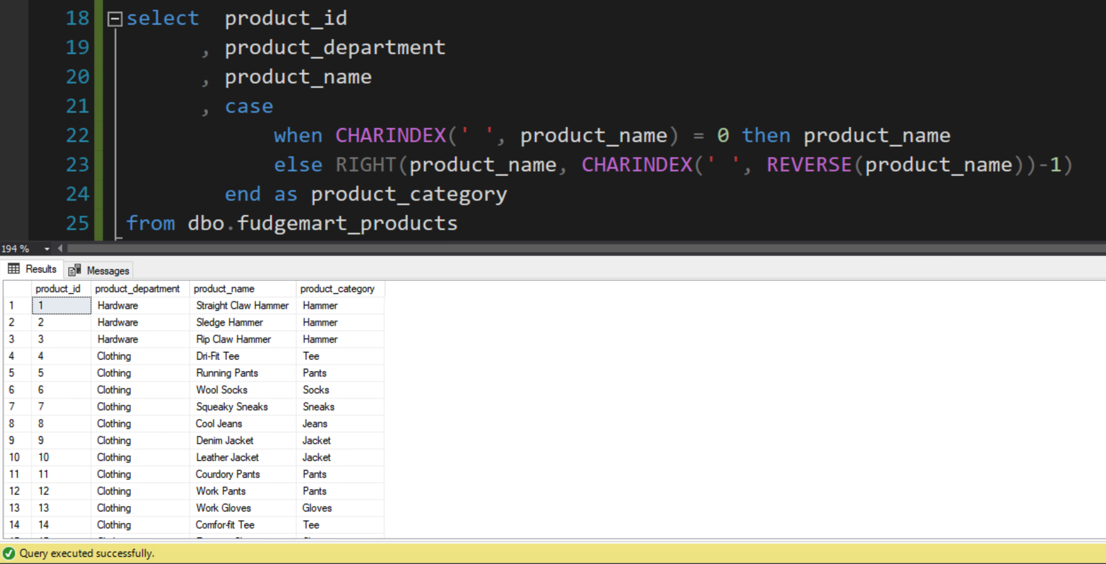

1. **Write a user defined function called f_total_vendor_sales which calculates the sum of the wholesale price * quantity of all products sold for that vendor. There should be one number associated with each vendor id, which is the input into the function. Demonstrate the function works by executing an SQL select statement over all vendors calling the function.**

**Solution:**

IF EXISTS (SELECT * FROM INFORMATION_SCHEMA.ROUTINES WHERE ROUTINE_NAME='f_total_vendor_Sales')

BEGIN

DROP FUNCTION f_total_vendor_Sales

END

GO

CREATE FUNCTION

dbo.f_total_vendor_Sales(@vendor_id int)

RETURNS money

AS

BEGIN

DECLARE @returnValue money -- data type matches RETURN Value

/* Get vendor_id from the function call as parameter that matches the vendor_id from the products ordered and return the calculated value to variable @returnvalue. */

SELECT

@returnValue = sum(isnull(p.product_wholesale_price * o.order_qty,0))

FROM dbo.fudgemart_vendors as v

join dbo.fudgemart_products as p ON v.vendor_id = p.product_vendor_id

join dbo.fudgemart_order_details as o ON o.product_id = p.product_id

where v.vendor_id = @vendor_id

RETURN @returnValue

END

GO

----- Validation:

--declare @vendor_id int

--set @vendor_id = 1

Select

vendor_name + ' has made $'

+ isnull(cast(dbo.f_total_vendor_Sales(vendor_id) as nvarchar(max)),0)

+ ' in total sales' as fudgemart_sales_by_vendor

from dbo.fudgemart_vendors

--where vendor_id = @vendor_id

go

**Evidence:**

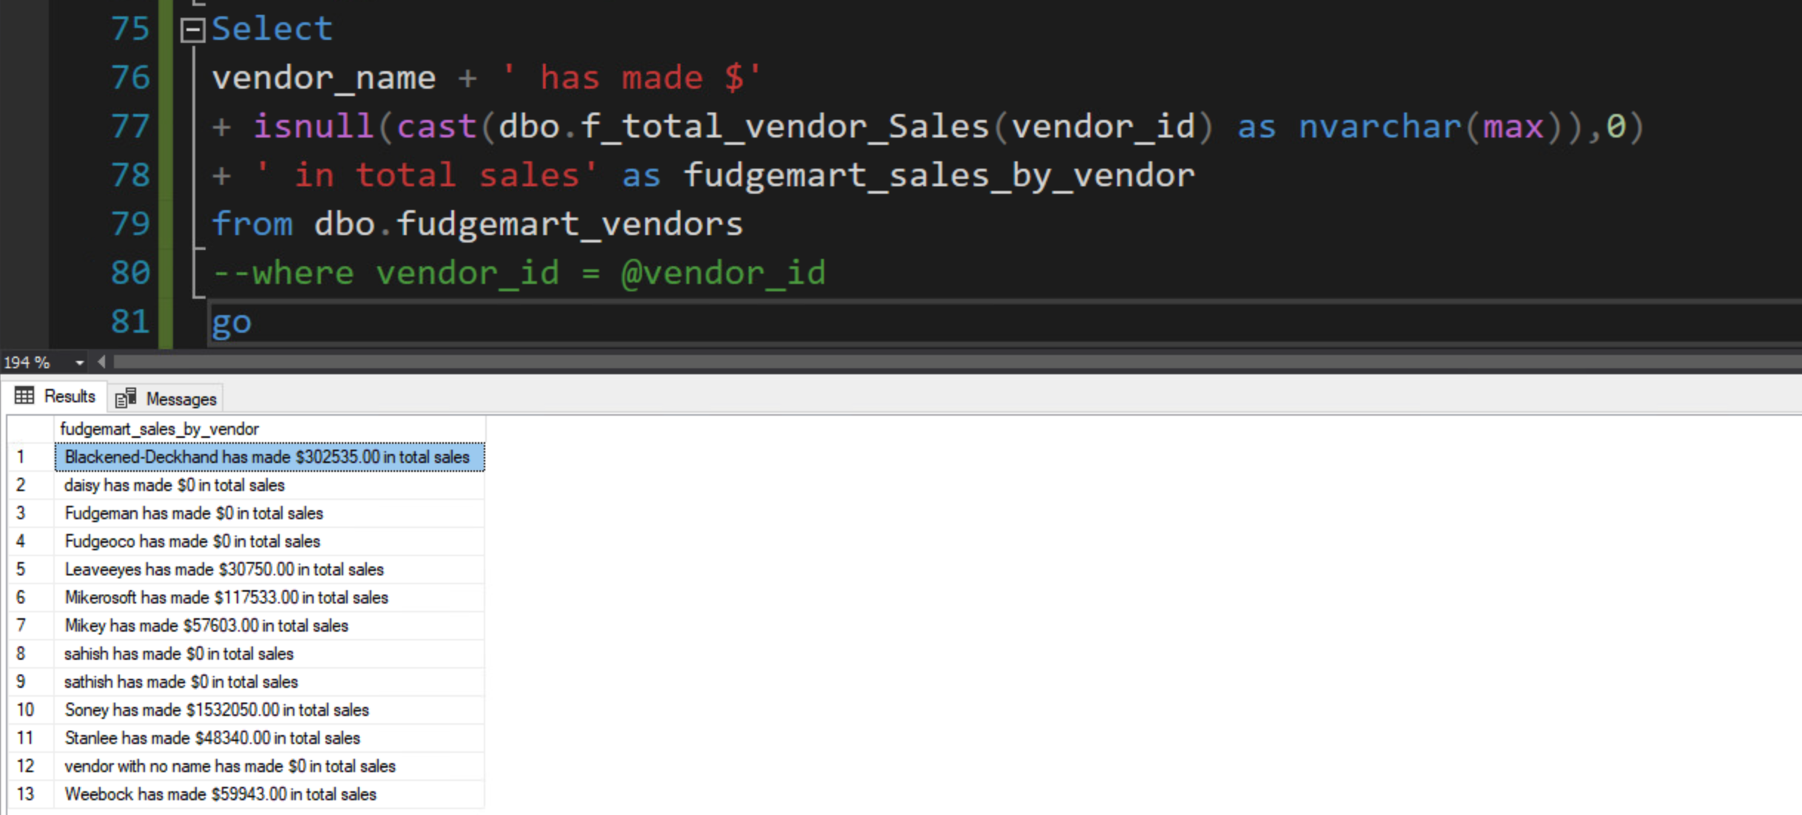

1. **Write a stored procedure called p_write_vendor which when given a required vendor name, phone and optional website, will look up the vendor by name first. If the vendor exists, it will update the phone and website. If the vendor does not exist, it will add the info to the table. Write code to demonstrate the procedure works by executing the procedure twice so that it adds a new vendor and then updates that vendor’s information.**

**Solution:**

IF EXISTS (SELECT * FROM INFORMATION_SCHEMA.ROUTINES WHERE ROUTINE_NAME='p_write_vendor')

BEGIN

DROP PROCEDURE p_write_vendor

END

GO

CREATE PROCEDURE

dbo.p_write_vendor(

@vendor_name varchar(50),

@phone varchar(20),

@website varchar(1000))

AS

BEGIN

declare @vendor_id int

IF not exists(select * from dbo.fudgemart_vendors where vendor_name = isnull(@vendor_name,'vendor with no name'))

BEGIN

--Now we can add the row using an INSERT Statement

INSERT INTO dbo.fudgemart_vendors (vendor_name,vendor_phone,vendor_website)

VALUES (isnull(@vendor_name,'vendor with no name'), isnull(@phone,'000-0000'), @website)

-- pull the vendor id from the newly inserted record

select @vendor_id = vendor_id from dbo.fudgemart_vendors where vendor_name = isnull(@vendor_name,'vendor with no name')

END

ELSE

BEGIN

select @vendor_id = vendor_id from dbo.fudgemart_vendors where vendor_name = isnull(@vendor_name,'vendor with no name')

-- now we can update the vendors detail

UPDATE dbo.fudgemart_vendors

SET vendor_phone = isnull(@phone,'000-0000'),

vendor_website = @website

WHERE vendor_id = @vendor_id

END

--Return the affected row

select * from dbo.fudgemart_vendors

where vendor_id= @vendor_id

END

GO

------Udate/Insert into p_write_vendor table

EXEC dbo.p_write_vendor @vendor_name=NULL, @phone=NULL, @website='www.syr.edu'

GO

EXEC dbo.p_write_vendor @vendor_name='daisy', @phone='792-1234', @website=NULL

GO

EXEC dbo.p_write_vendor @vendor_name='daisy', @phone='792-1234', @website='www.liver-more.edu'

GO

**Evidence:**

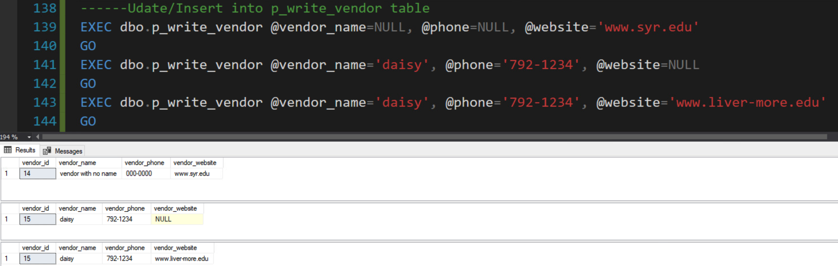

1. **Create a view based on the logic you completed in question 1 or 2. Your SQL script should be programmed so that the entire script works every time, dropping the view if it exists, and then re-creating it.**

**Solution:**

IF EXISTS (SELECT * FROM INFORMATION_SCHEMA.VIEWS WHERE TABLE_NAME='vw_product_details')

BEGIN

DROP VIEW vw_product_details

END

GO

CREATE VIEW dbo.vw_product_details

AS

select

product_id

, product_department

, product_name

, case

when CHARINDEX(' ', product_name) = 0 then product_name

else RIGHT(product_name, CHARINDEX(' ', REVERSE(product_name))-1)

end as product_category

from dbo.fudgemart_products

GO

----Retrive values from the vw_product_details View

SELECT * FROM vw_product_details

GO

----- vw_vendor_sales - Creation

----- This view returns total sales by vendors. Refer #2 from excercise above */

IF EXISTS (SELECT * FROM INFORMATION_SCHEMA.VIEWS WHERE TABLE_NAME='vw_vendor_sales')

BEGIN

DROP VIEW vw_vendor_sales

END

GO

CREATE VIEW dbo.vw_vendor_sales

AS

Select

vendor_name + ' has made $'

+ isnull(cast(dbo.f_total_vendor_Sales(vendor_id) as nvarchar(max)),0)

+ ' in total sales' as fudgemart_sales_by_vendor

from dbo.fudgemart_vendors

GO

----Retrive values from the vw_vendor_sales View

SELECT * FROM vw_vendor_sales

GO

**Evidence:**

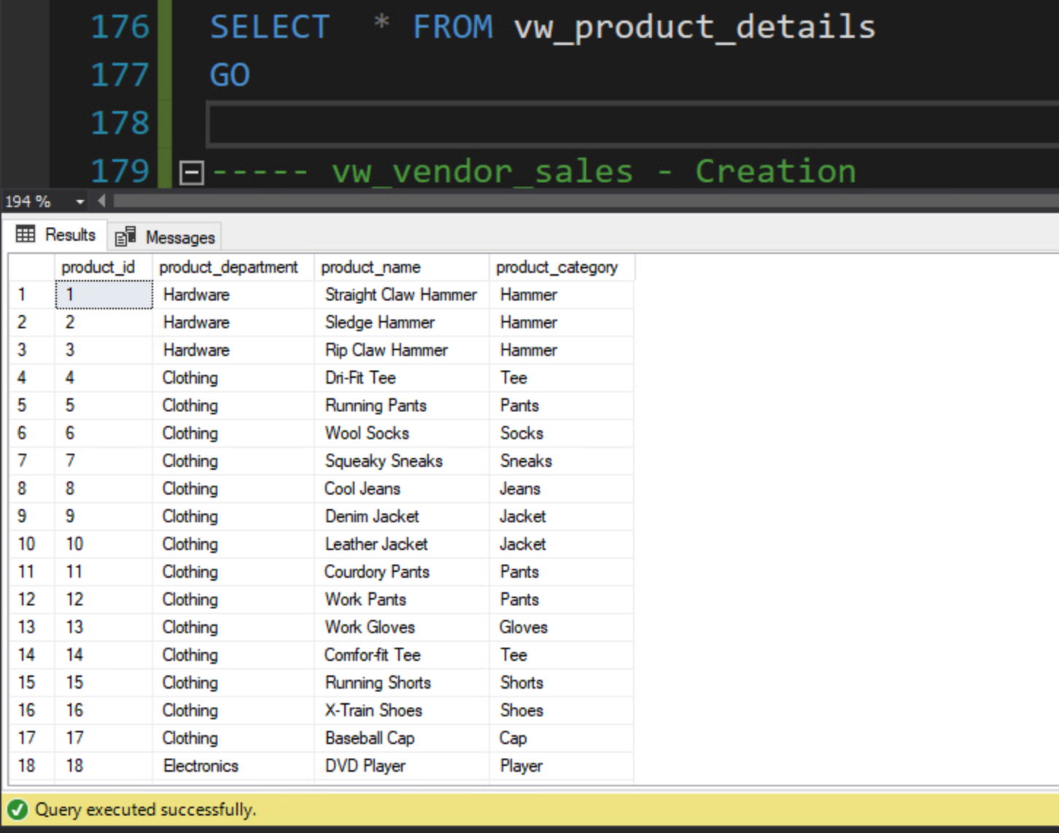

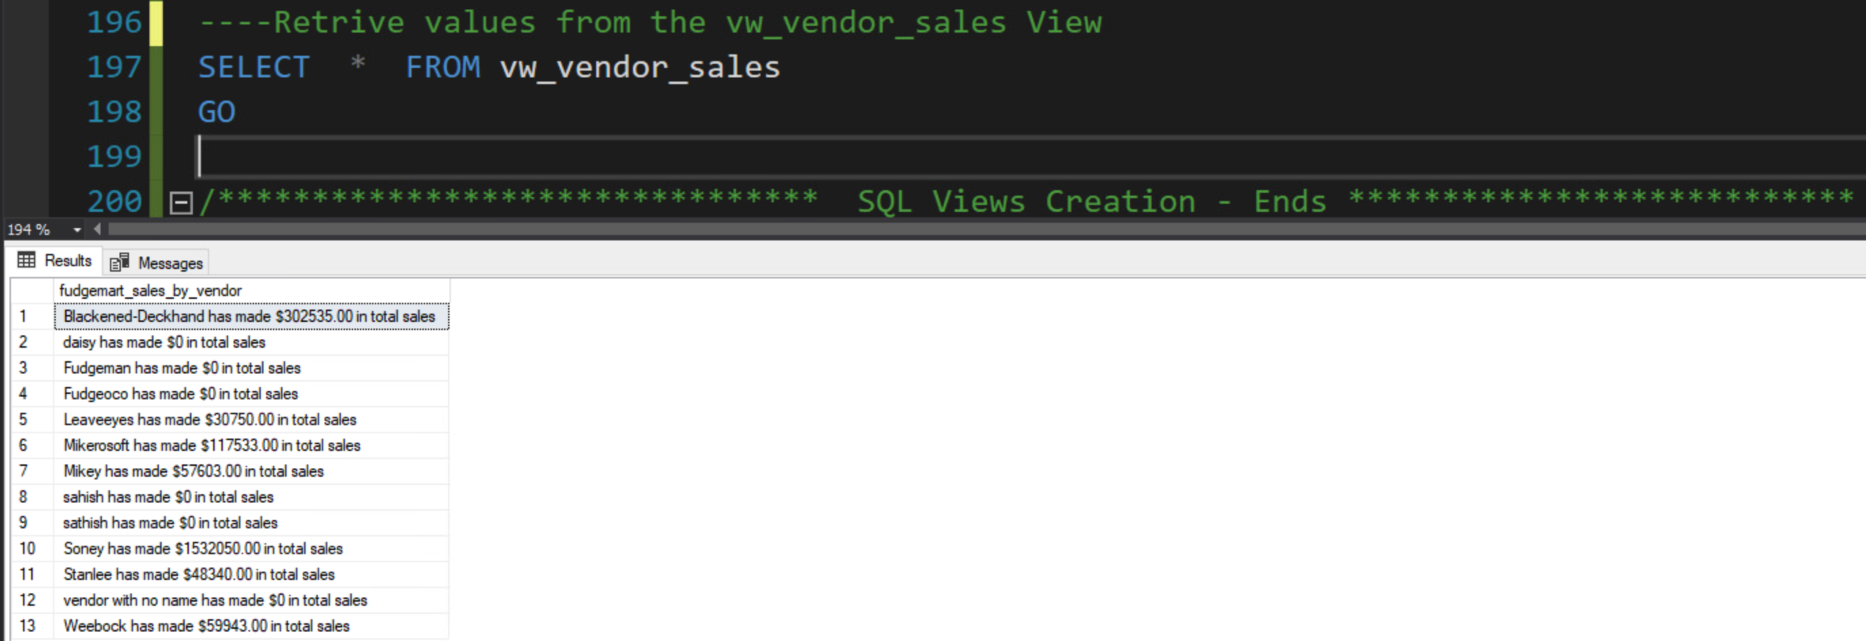

**5. Write a table valued function f_employee_timesheets which when provided an employee_id will output the employee id, name, department, payroll date, hourly rate on the timesheet, hours worked, and gross pay (hourly rate times hours worked).**

**Solution:**

IF EXISTS (SELECT * FROM INFORMATION_SCHEMA.ROUTINES WHERE ROUTINE_NAME='f_employee_timesheets')

BEGIN

DROP FUNCTION f_employee_timesheets

END

GO

CREATE FUNCTION dbo.f_employee_timesheets(

@employee_id INT

)

RETURNS TABLE

AS

RETURN (

SELECT

e.employee_id

, e.employee_lastname +', ' +e.employee_firstname as name

, e.employee_department as department

, cast(t.timesheet_payrolldate as date) as payrolldate

, round(isnull(t.timesheet_hourlyrate,0),2) as timesheet_hourly_rate

, isnull(t.timesheet_hours,0) as hours_worked

, cast(isnull(t.timesheet_hours * t.timesheet_hourlyrate,0) as decimal(9,2)) as grosspay

FROM dbo.fudgemart_employee_timesheets as t

Join dbo.fudgemart_employees as e ON e.employee_id = t.timesheet_employee_id

WHERE e.employee_id = @employee_id

);

GO

----- Validation:

Select top 5 * from dbo.f_employee_timesheets(10)

GO

**Evidence:**

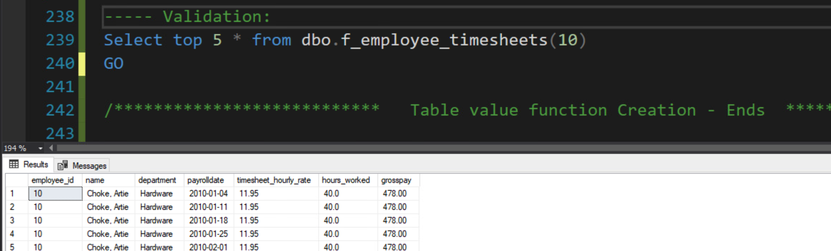

# **Appendix**

